Digital Yacht earn Queen’s Award For Enterprise
Bristol, UK : STRICT EMBARGO UNTIL 21 APRIL 2022
Back in April 2010, Icelandic Volcano Eyjafjallajokull erupted and shut down airspace around Europe. A volcanic cloud razed the global aviation industry just like the Covid pandemic with flights terminated for weeks.
Nick Heyes, founder of UK, Bristol based Digital Yacht was in Shenzhen, opening a China office to develop products with the help of a Bristol university graduate who had been working for the start up in the UK.
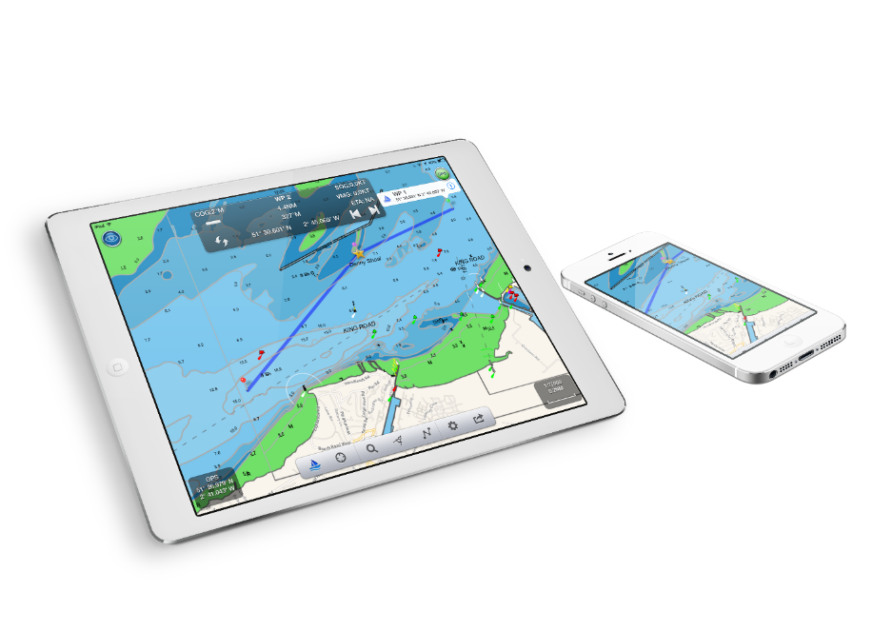
“We had an idea that China would be a great recreational boating market and a source of engineering expertise at the time” said Nick. “We had created a Shanghai company and development centre with 6 people to complement our UK operation and I was due to go back to the UK. I arrived at the airport to see a full screen of cancelled flights. I was not going home and spent 2 weeks waiting in Asia.”
It was also the launch of Apple’s first iPad and of course, the cany traders of Hong Kong had supplies available in Mongkok. “I had to buy one. I saw this as being the next generation marine navigation gizmo and realised that if we made a wireless device that linked traditional marine electronic instruments to this new consumer device we had an attractive solution” said Nick.
“Our UK team set to work and by 2011 had a revolutionary product called iAIS which picked up signals from ships and sent signals over wifi to an iPad onto a detailed chart so boaters could visualise their position and those of other ships and navigate safely”
It was a first and won the prestigious marine industry DAME Award at the showcase METS exhibition in Amsterdam for the Electronics Category in 2011. “That volcano fired us up plus the iPad revolution” said Nick.
Today, Digital Yacht were awarded the prestigious Queens Award for Enterprise for exports to over 100 countries and export sales up more than 50% over the past 3 years despite Covid. Exports represent over 70% of revenues.
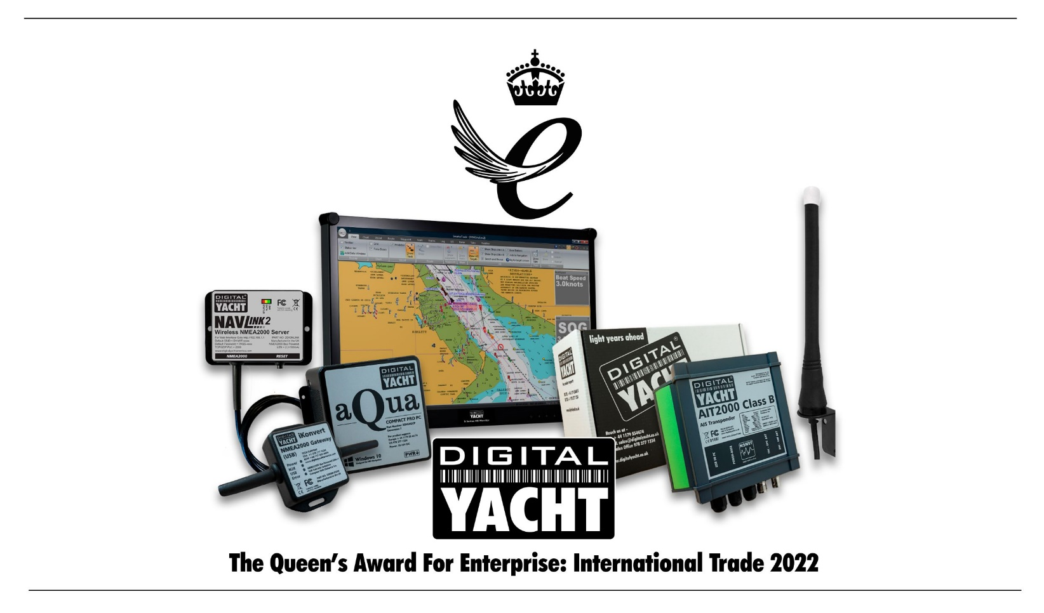
China hasn’t been the export market or the development centre for Digital Yacht. Instead, they manufacture locally in the UK, use a loyal group of local contractors and have a lean production and global marketing process for developing their growing range of marine navigation and communication products.
“We hope China will become a growing market for recreational boating at some stage and we’re ready” said Nick. “But we’re committed to using the UK as our centre of expertise.” Last year, they opened a logistics, sales and marketing facility in Rouen, France for European customers and their US Boston office looks after North America and Canada.
“Moving forward, we’re developing AI products for marine navigation to make it safer, easier and more fun for the growing, global leisure sector who want to get afloat and get a boat. New products like our 4G Xtream offer internet access on board and we also make products that allow legacy, older electronics to connect to newer systems for the after-market.”
-ENDS-
Embargoed until 21 April 2022
For more information contact: Nick Heyes + 44 7973 223287 (US 978 277 1234) nick@digitalyacht.co.uk
UK Website digitalyacht.co.uk
Media Library: media.digitalyacht.co.uk
Newsroom: https://digitalyacht.mynewsdesk.com/

