Customer’s Name
E-mail Address
VESSEL INFORMATION
Enter the following information.
MMSI number (9 digits):
Vessel Name (20 characters):
Call Sign (If applicable):
Determine position of GPS antenna on vessel. Round distance to nearest meter (3.3 feet)
(A) Distance from bow to the GPS antenna | meters | 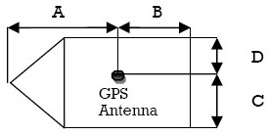
(B) Distance from stern to the GPS antenna | meters
(C) Distance from the port side to the GPS antenna | meters
(D) Distance from the starboard side to the GPS antenna | meters
Type of Vessel and record
*** IMPORTANT ***
Please double check all of the above information before returning this form to Digital Yacht
In particular the MMSI number cannot be easily changed so particular attention should be paid to ensuring this number is correctly recorded.

Please return this form to;
Digital Yacht Limited
6 Farleigh Court
Old Weston Road
Flax Bourton
Bristol
BS48 1UR
United Kingdom
Tel: +44 1179 554474
E-Mail: support@digitalyacht.co.uk

